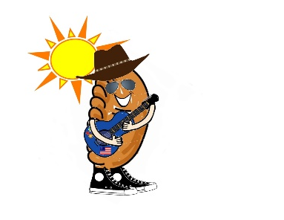
Haralson County Historical Society
P.O. Box 585
Buchanan, GA 30113

www.haralsoncountyhistory.com

Dear Friend,

The Haralson County Historical Society is in the planning stages of the fourth annual Haralson Fried Pie Festival to be held Saturday, September 21, 2019. The Historical Society has held a festival in the Fall for over 40 years. Plans for this year’s festival include multiple stages of entertainment, a fried pie cooking contest, car show, beauty pageant, a separate children’s activity area and more.

We expect this year’s festival to be even larger so please get your application turned in as soon as possible. We will do our best to see booths from different vendors do not sell the same type of item. Please complete your application thoroughly to help us accomplish this. And submit it promptly to avoid rejection due to merchandise duplication. Also, please make sure you read the “vendor rules” completely!!

NOTE: please remember there are very limited electricity spaces…and the majority are around the Courthouse. If you want a spot around the Courthouse they are “preferred” spaces and are first come first served and are $70 each spot. A $10 discount will be applied to Fried Pie Contest Participant vendors (see application)

Your completed application and payment can be sent to the above address. You can also go to www.haralsoncountyhistory.com to complete your application online and make payment through Pay Pal.

The Friends of the Library will hold their annual fundraising BBQ lunch so we are asking vendors to please refrain from selling ANY type of chopped BBQ. Other BBQ items will be considered but must be approved.

If you have any VENDOR questions, you may call 770-646-3369 or email countryfriedfest@gmail.com. General festival inquiries can be sent to the Gmail address.

Look forward to seeing you in September!!

Haralson County Historical Society

P.S. E-mailing the application and rules is much easier (and quicker) than snail mail so if you have an e-mail address, please make sure we have it!

